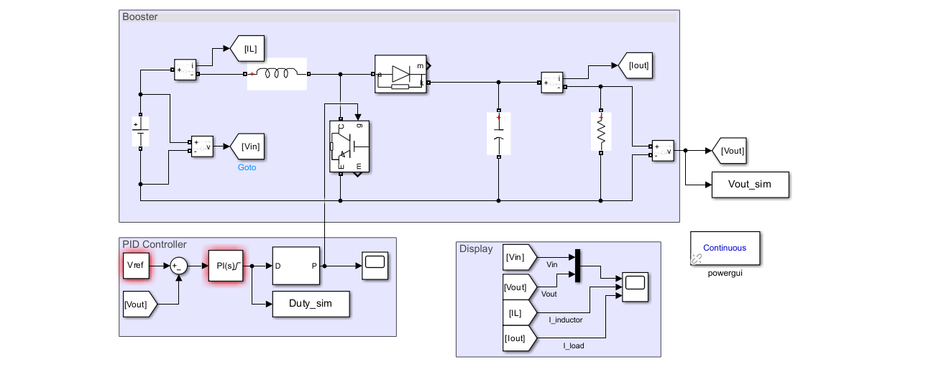
This is the Simulink figure for the pid boost converter model..
And here I will giving the details in step by step ..
- For the cfg.nRuns = 30; at kp=0; here I foudnd the data graph and all the others things
Here is the complete simulation data:-
Main_Run_All
PSO run 1/30 Kp=0.00000 Ki=0.40835 J=0.6261
PSO run 2/30 Kp=0.00000 Ki=0.40829 J=0.6262
PSO run 3/30 Kp=0.00000 Ki=0.40879 J=0.6261
PSO run 4/30 Kp=0.00000 Ki=0.40979 J=0.6261
PSO run 5/30 Kp=0.00000 Ki=0.40858 J=0.6261
PSO run 6/30 Kp=0.00000 Ki=0.40901 J=0.6261
PSO run 7/30 Kp=0.00000 Ki=0.40867 J=0.6261
PSO run 8/30 Kp=0.00000 Ki=0.40938 J=0.6261
PSO run 9/30 Kp=0.00000 Ki=0.40897 J=0.6261
PSO run 10/30 Kp=0.00000 Ki=0.41226 J=0.6261
PSO run 11/30 Kp=0.00000 Ki=0.41067 J=0.6262
PSO run 12/30 Kp=0.00000 Ki=0.40870 J=0.6262
PSO run 13/30 Kp=0.00000 Ki=0.40897 J=0.6261
PSO run 14/30 Kp=0.00000 Ki=0.40811 J=0.6262
PSO run 15/30 Kp=0.00000 Ki=0.40860 J=0.6261
PSO run 16/30 Kp=0.00000 Ki=0.40944 J=0.6262
PSO run 17/30 Kp=0.00000 Ki=0.40824 J=0.6261
PSO run 18/30 Kp=0.00000 Ki=0.40834 J=0.6261
PSO run 19/30 Kp=0.00000 Ki=0.40866 J=0.6261
PSO run 20/30 Kp=0.00000 Ki=0.40856 J=0.6261
PSO run 21/30 Kp=0.00000 Ki=0.40983 J=0.6262
PSO run 22/30 Kp=0.00000 Ki=0.40863 J=0.6261
PSO run 23/30 Kp=0.00000 Ki=0.40981 J=0.6261
PSO run 24/30 Kp=0.00000 Ki=0.40988 J=0.6262
PSO run 25/30 Kp=0.00000 Ki=0.41228 J=0.6261
PSO run 26/30 Kp=0.00000 Ki=0.41224 J=0.6261
PSO run 27/30 Kp=0.00000 Ki=0.40855 J=0.6261
PSO run 28/30 Kp=0.00000 Ki=0.41089 J=0.6262
PSO run 29/30 Kp=0.00000 Ki=0.40817 J=0.6261
PSO run 30/30 Kp=0.00000 Ki=0.40946 J=0.6262
>> PSO: best 0.6261 | mean 0.6261 | std 0.0000 | worst 0.6262

GWO run 1/30 Kp=0.00041 Ki=0.41265 J=0.6509
GWO run 2/30 Kp=0.00000 Ki=0.41079 J=0.6262
GWO run 3/30 Kp=0.00000 Ki=0.40906 J=0.6261
GWO run 4/30 Kp=0.00014 Ki=0.41106 J=0.6477
GWO run 5/30 Kp=0.00041 Ki=0.41170 J=0.6509
GWO run 6/30 Kp=0.00002 Ki=0.41831 J=0.6269
GWO run 7/30 Kp=0.00042 Ki=0.41003 J=0.6512
GWO run 8/30 Kp=0.00000 Ki=0.43171 J=0.6307
GWO run 9/30 Kp=0.00056 Ki=0.41142 J=0.6531
GWO run 10/30 Kp=0.00000 Ki=0.42820 J=0.6292
GWO run 11/30 Kp=0.00037 Ki=0.41496 J=0.6504
GWO run 12/30 Kp=0.00002 Ki=0.41442 J=0.6264
GWO run 13/30 Kp=0.00002 Ki=0.41778 J=0.6268
GWO run 14/30 Kp=0.00000 Ki=0.41462 J=0.6264
GWO run 15/30 Kp=0.00001 Ki=0.41205 J=0.6262
GWO run 16/30 Kp=0.00004 Ki=0.42345 J=0.6279
GWO run 17/30 Kp=0.00002 Ki=0.40268 J=0.6469
GWO run 18/30 Kp=0.00000 Ki=0.40848 J=0.6262
GWO run 19/30 Kp=0.00059 Ki=0.40910 J=0.6536
GWO run 20/30 Kp=0.00000 Ki=0.41801 J=0.6267
GWO run 21/30 Kp=0.00000 Ki=0.40833 J=0.6262
GWO run 22/30 Kp=0.00059 Ki=0.41107 J=0.6536
GWO run 23/30 Kp=0.00031 Ki=0.40750 J=0.6497
GWO run 24/30 Kp=0.00003 Ki=0.40146 J=0.6477
GWO run 25/30 Kp=0.00000 Ki=0.40889 J=0.6262
GWO run 26/30 Kp=0.00057 Ki=0.41536 J=0.6533
GWO run 27/30 Kp=0.00000 Ki=0.40902 J=0.6261
GWO run 28/30 Kp=0.00000 Ki=0.40776 J=0.6458
GWO run 29/30 Kp=0.00031 Ki=0.40630 J=0.6498
GWO run 30/30 Kp=0.00025 Ki=0.41334 J=0.6490
>> GWO: best 0.6261 | mean 0.6386 | std 0.0120 | worst 0.6536

GA run 1/30 Kp=0.00000 Ki=0.41231 J=0.6262
GA run 2/30 Kp=0.00205 Ki=0.40828 J=0.7149
GA run 3/30 Kp=0.00130 Ki=0.40450 J=0.6696
GA run 4/30 Kp=0.00000 Ki=0.41106 J=0.6262
GA run 5/30 Kp=0.00000 Ki=0.40621 J=0.6460
GA run 6/30 Kp=0.00000 Ki=0.40621 J=0.6460
GA run 7/30 Kp=0.00021 Ki=0.50446 J=0.7322
GA run 8/30 Kp=0.00327 Ki=0.36564 J=0.8103
GA run 9/30 Kp=0.00007 Ki=0.40719 J=0.6469
GA run 10/30 Kp=0.00009 Ki=0.37346 J=0.6953
GA run 11/30 Kp=0.00014 Ki=0.41231 J=0.6477
GA run 12/30 Kp=0.00003 Ki=0.41315 J=0.6462
GA run 13/30 Kp=0.00009 Ki=0.40630 J=0.6472
GA run 14/30 Kp=0.00024 Ki=0.40596 J=0.6492
GA run 15/30 Kp=0.00000 Ki=0.40841 J=0.6261
GA run 16/30 Kp=0.00113 Ki=0.40737 J=0.6652
GA run 17/30 Kp=0.00008 Ki=0.40841 J=0.6471
GA run 18/30 Kp=0.00000 Ki=0.40865 J=0.6261
GA run 19/30 Kp=0.00054 Ki=0.39591 J=0.6618
GA run 20/30 Kp=0.00010 Ki=0.41060 J=0.6471
GA run 21/30 Kp=0.00065 Ki=0.41817 J=0.6550
GA run 22/30 Kp=0.00009 Ki=0.40548 J=0.6473
GA run 23/30 Kp=0.00000 Ki=0.40497 J=0.6462
GA run 24/30 Kp=0.00000 Ki=0.40841 J=0.6261
GA run 25/30 Kp=0.00000 Ki=0.41461 J=0.6264
GA run 26/30 Kp=0.00000 Ki=0.40743 J=0.6458
GA run 27/30 Kp=0.00000 Ki=0.40743 J=0.6458
GA run 28/30 Kp=0.00000 Ki=0.40860 J=0.6261
GA run 29/30 Kp=0.00024 Ki=0.40554 J=0.6492
GA run 30/30 Kp=0.00009 Ki=0.34591 J=0.7605
>> GA: best 0.6261 | mean 0.6602 | std 0.0426 | worst 0.8103

--- Worst-case summary over all scenarios ---
<strong>Kp</strong> <strong>Ki</strong> <strong>ITAEn_max</strong> <strong>OS_max_pct</strong> <strong>Ts_max_ms</strong> <strong>PM_min_deg</strong> <strong>GM_min_dB</strong>
<strong>_________</strong> <strong>_______</strong> <strong>_________</strong> <strong>__________</strong> <strong>_________</strong> <strong>__________</strong> <strong>_________</strong>

<strong>Manual </strong> 0.0132 0.6867 0.088699 18.68 400 0 -10
<strong>Calculated</strong> 0.004 0.4045 0.059798 0.63317 288.79 33.661 4.9811
<strong>PIDTuner </strong> 0 0.8837 0.076626 15.207 400 0 -10
<strong>PSO </strong> 0 0.40855 0.055251 0.7577 254.25 67.531 5.8507
<strong>GWO </strong> 0 0.40902 0.055132 0.7598 253.95 67.504 5.8409
<strong>GA </strong> 0 0.40865 0.055226 0.75815 254.15 67.525 5.8486
<strong>NSGA2_knee</strong> 0.0035677 0.30468 0.10378 0.35002 373.55 85.541 7.1103

--- Overshoot [%] per scenario ---
<strong>Manual</strong> <strong>Calculated</strong> <strong>PIDTuner</strong> <strong>PSO</strong> <strong>GWO</strong> <strong>GA</strong> <strong>NSGA2_knee</strong>
<strong>_______</strong> <strong>__________</strong> <strong>________</strong> <strong>________</strong> <strong>________</strong> <strong>_______</strong> <strong>__________</strong>

<strong>Nominal</strong> 0.53133 0.43796 0.63202 0.5243 0.52455 0.52435 0
<strong>Vin-20%</strong> 1.1567 0.63317 13.239 0.7577 0.7598 0.75815 0.35002
<strong>Vin+20%</strong> 0.63194 0.20281 0.43804 0.34853 0.34941 0.34872 0
<strong>Load50%</strong> 0.98154 0.10677 0.38152 0.20961 0.21483 0.21184 0
<strong>Load20%</strong> 18.68 0.07526 15.207 0.099782 0.097232 0.10687 0
<strong>L-20% </strong> 0.52893 0.41589 0.53973 0.51451 0.51485 0.51458 0
<strong>C-20% </strong> 0.66697 0.57382 0.80566 0.65983 0.66007 0.65988 0

--- Settling time [ms] per scenario ---
<strong>Manual</strong> <strong>Calculated</strong> <strong>PIDTuner</strong> <strong>PSO</strong> <strong>GWO</strong> <strong>GA</strong> <strong>NSGA2_knee</strong>
<strong>______</strong> <strong>__________</strong> <strong>________</strong> <strong>______</strong> <strong>______</strong> <strong>______</strong> <strong>__________</strong>

<strong>Nominal</strong> 186.38 269.88 95.683 239.15 238.88 239.08 361.18
<strong>Vin-20%</strong> 169.3 241.8 391.26 203.9 203.6 203.76 328.69
<strong>Vin+20%</strong> 189.45 280.45 109.05 254.25 253.95 254.15 373.55
<strong>Load50%</strong> 221.48 271.67 113.16 244.19 243.98 243.98 358.48
<strong>Load20%</strong> 400 288.79 400 248.48 248.55 248.48 363.88
<strong>L-20% </strong> 189.85 273.98 101.38 244.05 243.78 243.95 365.28
<strong>C-20% </strong> 190.88 274.38 96.655 242.58 242.28 242.48 367.38

[Warning: PIDTuner hit a search bound - widen bounds.]
[> In <a href="matlab:matlab.lang.internal.introspective.errorDocCallback('Main_Run_All', 'C:\Users\Razowan\Downloads\Research File With Program and paper\Booster Tunned Research prject by RK\PSO Program\Main_Run_All.m', 101)" style="font-weight:bold">Main_Run_All</a> (<a href="matlab: opentoline('C:\Users\Razowan\Downloads\Research File With Program and paper\Booster Tunned Research prject by RK\PSO Program\Main_Run_All.m',101,0)">line 101</a>)]
[Warning: PSO hit a search bound - widen bounds.]
[> In <a href="matlab:matlab.lang.internal.introspective.errorDocCallback('Main_Run_All', 'C:\Users\Razowan\Downloads\Research File With Program and paper\Booster Tunned Research prject by RK\PSO Program\Main_Run_All.m', 101)" style="font-weight:bold">Main_Run_All</a> (<a href="matlab: opentoline('C:\Users\Razowan\Downloads\Research File With Program and paper\Booster Tunned Research prject by RK\PSO Program\Main_Run_All.m',101,0)">line 101</a>)]
[Warning: GWO hit a search bound - widen bounds.]
[> In <a href="matlab:matlab.lang.internal.introspective.errorDocCallback('Main_Run_All', 'C:\Users\Razowan\Downloads\Research File With Program and paper\Booster Tunned Research prject by RK\PSO Program\Main_Run_All.m', 101)" style="font-weight:bold">Main_Run_All</a> (<a href="matlab: opentoline('C:\Users\Razowan\Downloads\Research File With Program and paper\Booster Tunned Research prject by RK\PSO Program\Main_Run_All.m',101,0)">line 101</a>)]
[Warning: GA hit a search bound - widen bounds.]
[> In <a href="matlab:matlab.lang.internal.introspective.errorDocCallback('Main_Run_All', 'C:\Users\Razowan\Downloads\Research File With Program and paper\Booster Tunned Research prject by RK\PSO Program\Main_Run_All.m', 101)" style="font-weight:bold">Main_Run_All</a> (<a href="matlab: opentoline('C:\Users\Razowan\Downloads\Research File With Program and paper\Booster Tunned Research prject by RK\PSO Program\Main_Run_All.m',101,0)">line 101</a>)]
diary off
////////////////////data end here
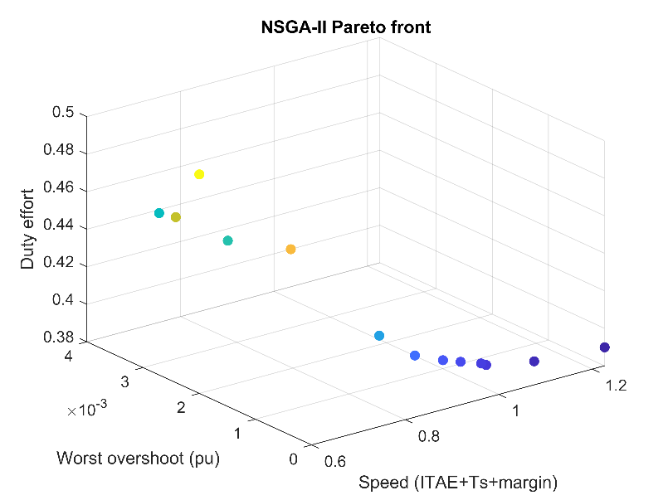
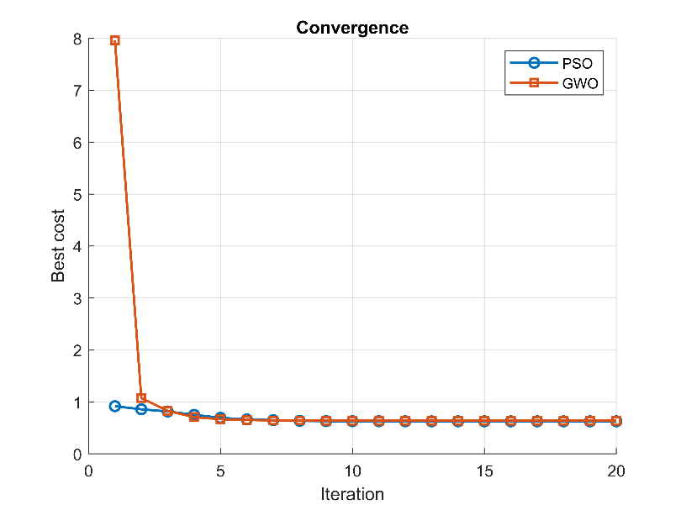
Now showing the figures step by step here
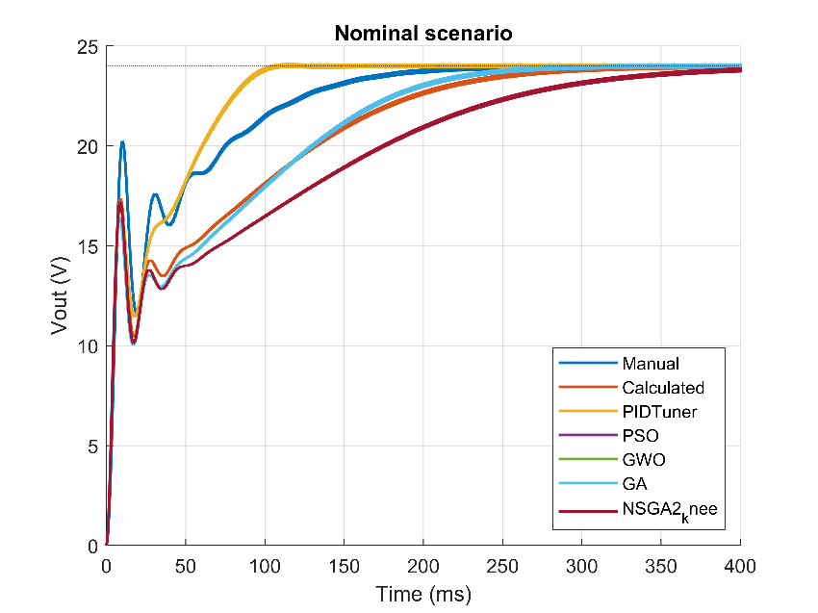
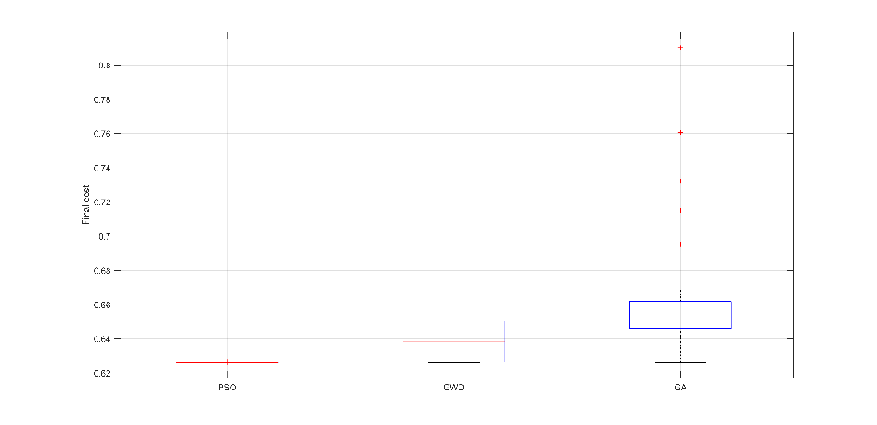
>> itPSO = arrayfun(@(r) find(R.PSO.H(r,:) <= R.PSO.H(r,end)*1.001,1), 1:size(R.PSO.H,1));
itGWO = arrayfun(@(r) find(R.GWO.H(r,:) <= R.GWO.H(r,end)*1.001,1), 1:size(R.GWO.H,1));
mean(itPSO), mean(itGWO)
ans =
8.6333
ans =
7.9333
Here is the end of the all data
Now for
- For the cfg.nRuns = 30; at kp=0.001; here I foudnd the data graph and all the others things
PSO run 1/30 Kp=0.00100 Ki=0.41505 J=0.6616
PSO run 2/30 Kp=0.00100 Ki=0.41318 J=0.6615
PSO run 3/30 Kp=0.00100 Ki=0.41494 J=0.6615
PSO run 4/30 Kp=0.00100 Ki=0.41495 J=0.6615
PSO run 5/30 Kp=0.00100 Ki=0.41402 J=0.6615
PSO run 6/30 Kp=0.00100 Ki=0.41477 J=0.6615
PSO run 7/30 Kp=0.00100 Ki=0.41398 J=0.6615
PSO run 8/30 Kp=0.00100 Ki=0.41472 J=0.6615
PSO run 9/30 Kp=0.00100 Ki=0.41282 J=0.6615
PSO run 10/30 Kp=0.00100 Ki=0.41478 J=0.6615
PSO run 11/30 Kp=0.00100 Ki=0.41402 J=0.6615
PSO run 12/30 Kp=0.00100 Ki=0.41475 J=0.6615
PSO run 13/30 Kp=0.00100 Ki=0.41473 J=0.6615
PSO run 14/30 Kp=0.00100 Ki=0.41474 J=0.6615
PSO run 15/30 Kp=0.00100 Ki=0.41356 J=0.6615
PSO run 16/30 Kp=0.00100 Ki=0.41448 J=0.6615
PSO run 17/30 Kp=0.00100 Ki=0.41473 J=0.6615
PSO run 18/30 Kp=0.00100 Ki=0.41279 J=0.6615
PSO run 19/30 Kp=0.00100 Ki=0.41363 J=0.6615
PSO run 20/30 Kp=0.00100 Ki=0.41359 J=0.6615
PSO run 21/30 Kp=0.00100 Ki=0.41354 J=0.6615
PSO run 22/30 Kp=0.00100 Ki=0.41324 J=0.6615
PSO run 23/30 Kp=0.00100 Ki=0.41474 J=0.6615
PSO run 24/30 Kp=0.00100 Ki=0.41435 J=0.6615
PSO run 25/30 Kp=0.00100 Ki=0.41358 J=0.6615
PSO run 26/30 Kp=0.00100 Ki=0.41409 J=0.6615
PSO run 27/30 Kp=0.00100 Ki=0.41474 J=0.6615
PSO run 28/30 Kp=0.00100 Ki=0.41465 J=0.6615
PSO run 29/30 Kp=0.00100 Ki=0.41330 J=0.6615
PSO run 30/30 Kp=0.00100 Ki=0.41368 J=0.6615
>> PSO: best 0.6615 | mean 0.6615 | std 0.0000 | worst 0.6616

GWO run 1/30 Kp=0.00100 Ki=0.41122 J=0.6616
GWO run 2/30 Kp=0.00100 Ki=0.41513 J=0.6615
GWO run 3/30 Kp=0.00100 Ki=0.41498 J=0.6615
GWO run 4/30 Kp=0.00100 Ki=0.41106 J=0.6616
GWO run 5/30 Kp=0.00101 Ki=0.41655 J=0.6619
GWO run 6/30 Kp=0.00100 Ki=0.41312 J=0.6615
GWO run 7/30 Kp=0.00102 Ki=0.40654 J=0.6626
GWO run 8/30 Kp=0.00100 Ki=0.41261 J=0.6616
GWO run 9/30 Kp=0.00100 Ki=0.41580 J=0.6617
GWO run 10/30 Kp=0.00100 Ki=0.41087 J=0.6616
GWO run 11/30 Kp=0.00100 Ki=0.40545 J=0.6623
GWO run 12/30 Kp=0.00100 Ki=0.41409 J=0.6615
GWO run 13/30 Kp=0.00100 Ki=0.41151 J=0.6616
GWO run 14/30 Kp=0.00100 Ki=0.41400 J=0.6615
GWO run 15/30 Kp=0.00100 Ki=0.41357 J=0.6615
GWO run 16/30 Kp=0.00100 Ki=0.41453 J=0.6615
GWO run 17/30 Kp=0.00100 Ki=0.41413 J=0.6615
GWO run 18/30 Kp=0.00100 Ki=0.40466 J=0.6623
GWO run 19/30 Kp=0.00100 Ki=0.41366 J=0.6615
GWO run 20/30 Kp=0.00100 Ki=0.41123 J=0.6616
GWO run 21/30 Kp=0.00100 Ki=0.41362 J=0.6615
GWO run 22/30 Kp=0.00100 Ki=0.41484 J=0.6615
GWO run 23/30 Kp=0.00100 Ki=0.41371 J=0.6615
GWO run 24/30 Kp=0.00100 Ki=0.41366 J=0.6615
GWO run 25/30 Kp=0.00100 Ki=0.41009 J=0.6618
GWO run 26/30 Kp=0.00100 Ki=0.41881 J=0.6622
GWO run 27/30 Kp=0.00100 Ki=0.41454 J=0.6615
GWO run 28/30 Kp=0.00100 Ki=0.41293 J=0.6616
GWO run 29/30 Kp=0.00100 Ki=0.40818 J=0.6620
GWO run 30/30 Kp=0.00100 Ki=0.41155 J=0.6616
>> GWO: best 0.6615 | mean 0.6617 | std 0.0003 | worst 0.6626

GA run 1/30 Kp=0.00100 Ki=0.41207 J=0.6617
GA run 2/30 Kp=0.00205 Ki=0.40828 J=0.7149
GA run 3/30 Kp=0.00205 Ki=0.37340 J=0.7471
GA run 4/30 Kp=0.00151 Ki=0.40262 J=0.6958
GA run 5/30 Kp=0.00400 Ki=0.39278 J=0.9326
GA run 6/30 Kp=0.00143 Ki=0.40938 J=0.6728
GA run 7/30 Kp=0.00149 Ki=0.41427 J=0.6744
GA run 8/30 Kp=0.00205 Ki=0.36578 J=0.7632
GA run 9/30 Kp=0.00130 Ki=0.40938 J=0.6690
GA run 10/30 Kp=0.00382 Ki=0.35860 J=0.8693
GA run 11/30 Kp=0.00125 Ki=0.40550 J=0.6681
GA run 12/30 Kp=0.00124 Ki=0.36082 J=0.7595
GA run 13/30 Kp=0.00302 Ki=0.37716 J=0.7880
GA run 14/30 Kp=0.00111 Ki=0.40450 J=0.6650
GA run 15/30 Kp=0.00107 Ki=0.41641 J=0.6635
GA run 16/30 Kp=0.00109 Ki=0.40529 J=0.6642
GA run 17/30 Kp=0.00205 Ki=0.36544 J=0.7639
GA run 18/30 Kp=0.00205 Ki=0.34426 J=0.8173
GA run 19/30 Kp=0.00383 Ki=0.35763 J=0.8729
GA run 20/30 Kp=0.00400 Ki=0.36348 J=0.9167
GA run 21/30 Kp=0.00114 Ki=0.41396 J=0.6649
GA run 22/30 Kp=0.00156 Ki=0.40548 J=0.6972
GA run 23/30 Kp=0.00205 Ki=0.34378 J=0.8187
GA run 24/30 Kp=0.00205 Ki=0.38106 J=0.7326
GA run 25/30 Kp=0.00357 Ki=0.39669 J=0.8344
GA run 26/30 Kp=0.00163 Ki=0.37813 J=0.7297
GA run 27/30 Kp=0.00118 Ki=0.41231 J=0.6658
GA run 28/30 Kp=0.00134 Ki=0.34591 J=0.8005
GA run 29/30 Kp=0.00117 Ki=0.40178 J=0.6670
GA run 30/30 Kp=0.00302 Ki=0.38560 J=0.7840
>> GA: best 0.6617 | mean 0.7458 | std 0.0821 | worst 0.9326

--- Worst-case summary over all scenarios ---
<strong>Kp</strong> <strong>Ki</strong> <strong>ITAEn_max</strong> <strong>OS_max_pct</strong> <strong>Ts_max_ms</strong> <strong>PM_min_deg</strong> <strong>GM_min_dB</strong>
<strong>_________</strong> <strong>_______</strong> <strong>_________</strong> <strong>__________</strong> <strong>_________</strong> <strong>__________</strong> <strong>_________</strong>

<strong>Manual </strong> 0.0132 0.6867 0.088699 18.68 400 0 -10
<strong>Calculated</strong> 0.004 0.4045 0.059798 0.63317 288.79 33.661 4.9811
<strong>PIDTuner </strong> 0 0.8837 0.076626 15.207 400 0 -10
<strong>PSO </strong> 0.001 0.41473 0.05436 0.65236 256.05 70.655 5.6774
<strong>GWO </strong> 0.001 0.41357 0.054656 0.65153 256.85 70.722 5.7013
<strong>GA </strong> 0.0010749 0.41641 0.053993 0.6526 255.35 70.816 5.6333
<strong>NSGA2_knee</strong> 0.0040908 0.2885 0.11643 0.058453 399.45 45.057 7.1073

--- Overshoot [%] per scenario ---
<strong>Manual</strong> <strong>Calculated</strong> <strong>PIDTuner</strong> <strong>PSO</strong> <strong>GWO</strong> <strong>GA</strong> <strong>NSGA2_knee</strong>
<strong>_______</strong> <strong>__________</strong> <strong>________</strong> <strong>_______</strong> <strong>_______</strong> <strong>_______</strong> <strong>__________</strong>

<strong>Nominal</strong> 0.53133 0.43796 0.63202 0.51682 0.51599 0.51707 0
<strong>Vin-20%</strong> 1.1567 0.63317 13.239 0.64191 0.6419 0.6419 0.058453
<strong>Vin+20%</strong> 0.63194 0.20281 0.43804 0.33516 0.33271 0.33667 0
<strong>Load50%</strong> 0.98154 0.10677 0.38152 0.2132 0.21168 0.21394 0
<strong>Load20%</strong> 18.68 0.07526 15.207 0.10192 0.10151 0.11317 0
<strong>L-20% </strong> 0.52893 0.41589 0.53973 0.50565 0.50456 0.50607 0
<strong>C-20% </strong> 0.66697 0.57382 0.80566 0.65236 0.65153 0.6526 0

--- Settling time [ms] per scenario ---
<strong>Manual</strong> <strong>Calculated</strong> <strong>PIDTuner</strong> <strong>PSO</strong> <strong>GWO</strong> <strong>GA</strong> <strong>NSGA2_knee</strong>
<strong>______</strong> <strong>__________</strong> <strong>________</strong> <strong>______</strong> <strong>______</strong> <strong>______</strong> <strong>__________</strong>

<strong>Nominal</strong> 186.38 269.88 95.683 242.27 242.98 241.68 387.35
<strong>Vin-20%</strong> 169.3 241.8 391.26 208.39 209.16 208 355
<strong>Vin+20%</strong> 189.45 280.45 109.05 256.05 256.85 255.35 399.45
<strong>Load50%</strong> 221.48 271.67 113.16 246.75 247.45 246.17 384.08
<strong>Load20%</strong> 400 288.79 400 247.48 247.57 247.16 388.89
<strong>L-20% </strong> 189.85 273.98 101.38 246.98 247.68 246.35 391.38
<strong>C-20% </strong> 190.88 274.38 96.655 245.85 246.68 245.28 394.28

[Warning: PSO hit a search bound - widen bounds.]
[> In <a href="matlab:matlab.lang.internal.introspective.errorDocCallback('Main_Run_All', 'C:\Users\Razowan\Downloads\Research File With Program and paper\Booster Tunned Research prject by RK\PSO Program\Main_Run_All.m', 101)" style="font-weight:bold">Main_Run_All</a> (<a href="matlab: opentoline('C:\Users\Razowan\Downloads\Research File With Program and paper\Booster Tunned Research prject by RK\PSO Program\Main_Run_All.m',101,0)">line 101</a>)]
[Warning: GWO hit a search bound - widen bounds.]
[> In <a href="matlab:matlab.lang.internal.introspective.errorDocCallback('Main_Run_All', 'C:\Users\Razowan\Downloads\Research File With Program and paper\Booster Tunned Research prject by RK\PSO Program\Main_Run_All.m', 101)" style="font-weight:bold">Main_Run_All</a> (<a href="matlab: opentoline('C:\Users\Razowan\Downloads\Research File With Program and paper\Booster Tunned Research prject by RK\PSO Program\Main_Run_All.m',101,0)">line 101</a>)]

now showing the figures step by step here
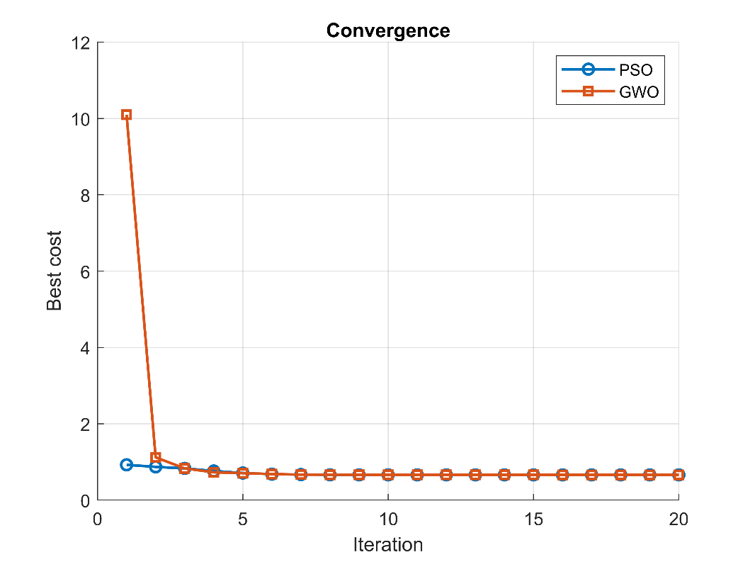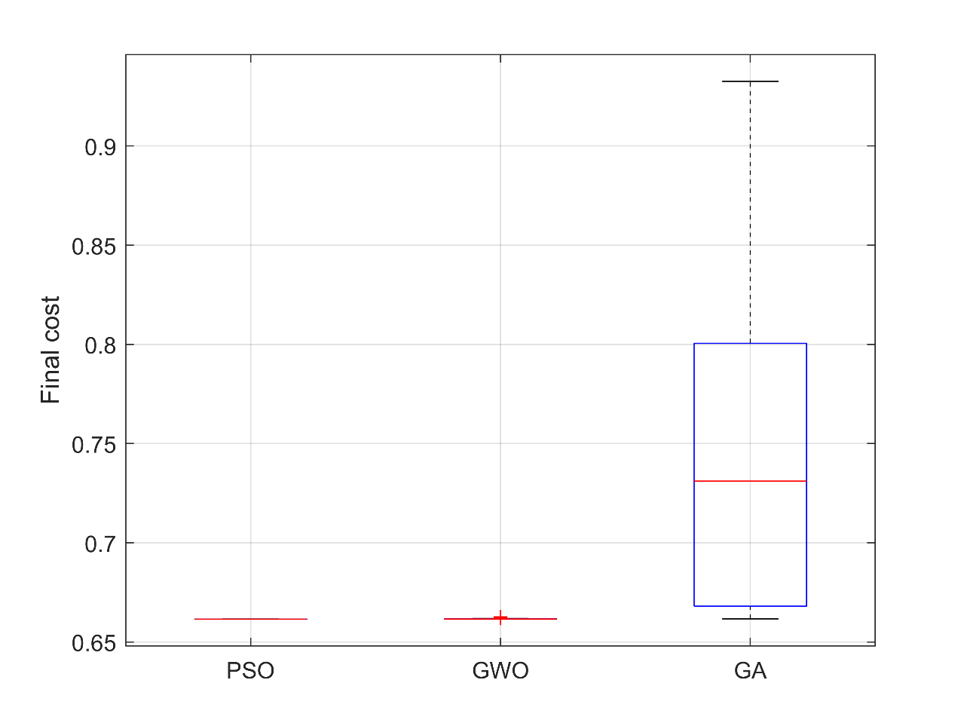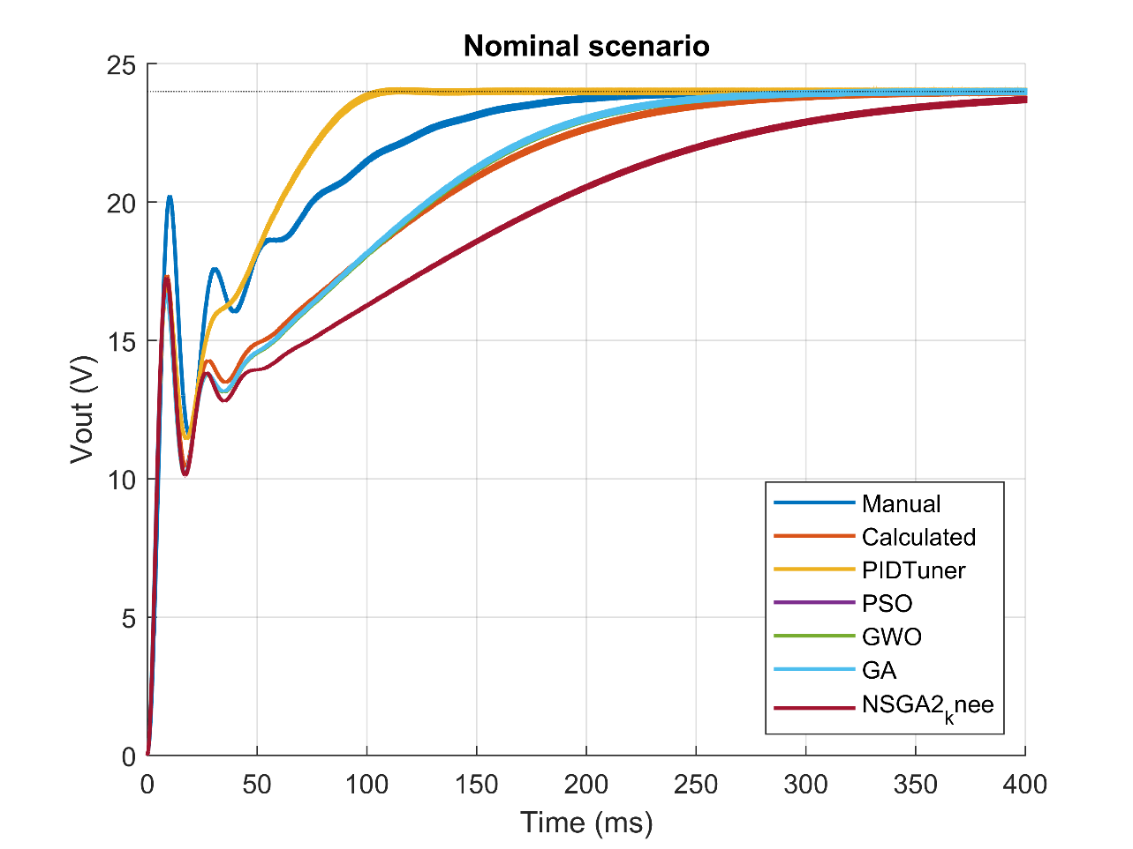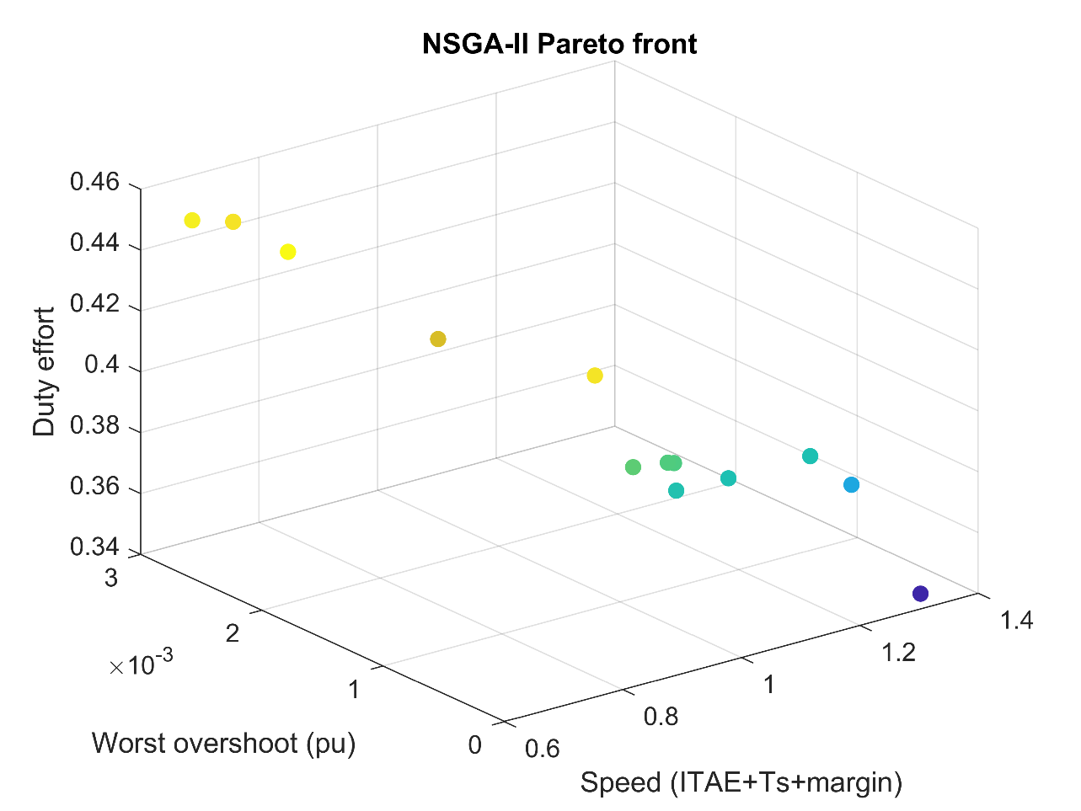
And other few data is
>> //////////////////// for the test case kp=.001 at 30 size itteration
>> load('results_B_Kp001.mat');
J1 = R.PSO.J; J2 = R.GWO.J; J3 = R.GA.J;
p_PSO_GWO = ranksum(J1,J2)
p_PSO_GA = ranksum(J1,J3)
p_GWO_GA = ranksum(J2,J3)
Jbest = min([J1;J2;J3]);
success = [mean(J1<=Jbest*1.001) mean(J2<=Jbest*1.001) mean(J3<=Jbest*1.001)]
figure; boxplot([J1 J2 J3],'Labels',{'PSO','GWO','GA'}); ylabel('Final cost'); grid on

p_PSO_GWO =

8.2919e-06

p_PSO_GA =

3.0199e-11

p_GWO_GA =

6.6955e-11

success =

1.0000 0.8667 0.0333

>> itPSO = arrayfun(@(r) find(R.PSO.H(r,:) <= R.PSO.H(r,end)*1.001,1), 1:size(R.PSO.H,1));
itGWO = arrayfun(@(r) find(R.GWO.H(r,:) <= R.GWO.H(r,end)*1.001,1), 1:size(R.GWO.H,1));
mean(itPSO), mean(itGWO)

ans =

7.5000

ans =

8.2333

>>

